Hexagonal Antiprism
# Source: AI Source: Provided by: [Data Path: Persons Table -> ID Column: 1, Name_En Column: Motasem Essam] -> From: [ChatGPT] on [7/25/2026]
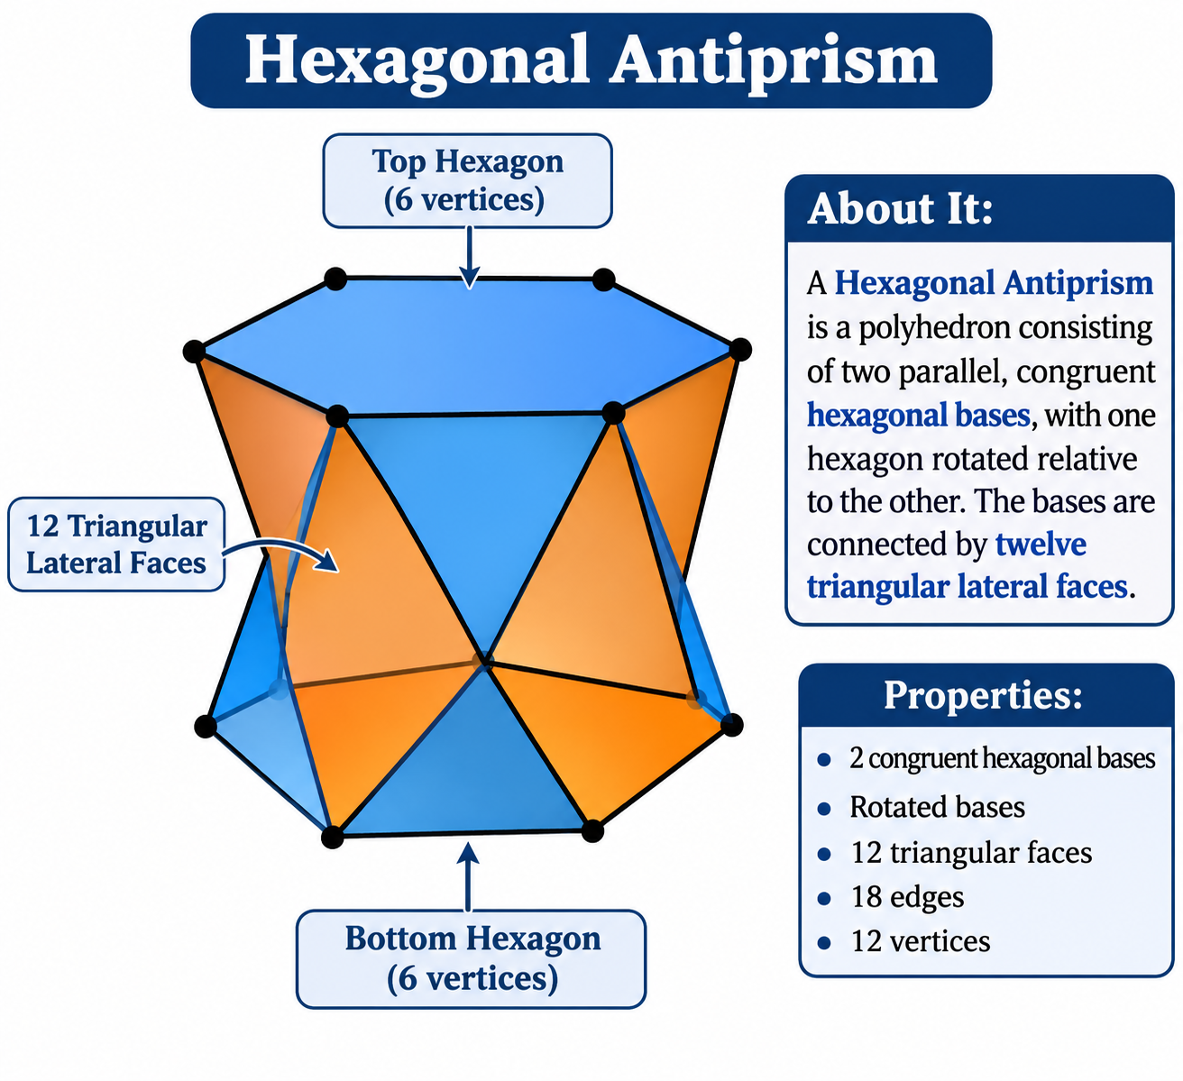

Definition
# Source: AI Source: Provided by: [Data Path: Persons Table -> ID Column: 1, Name_En Column: Motasem Essam] -> From: [ChatGPT] on [7/25/2026]
A Hexagonal Antiprism is a polyhedron consisting of two parallel, congruent hexagonal bases, with one hexagon rotated relative to the other. The bases are connected by twelve triangular lateral faces.
It is a type of antiprism with hexagonal bases and a twisted arrangement of its lateral triangles.
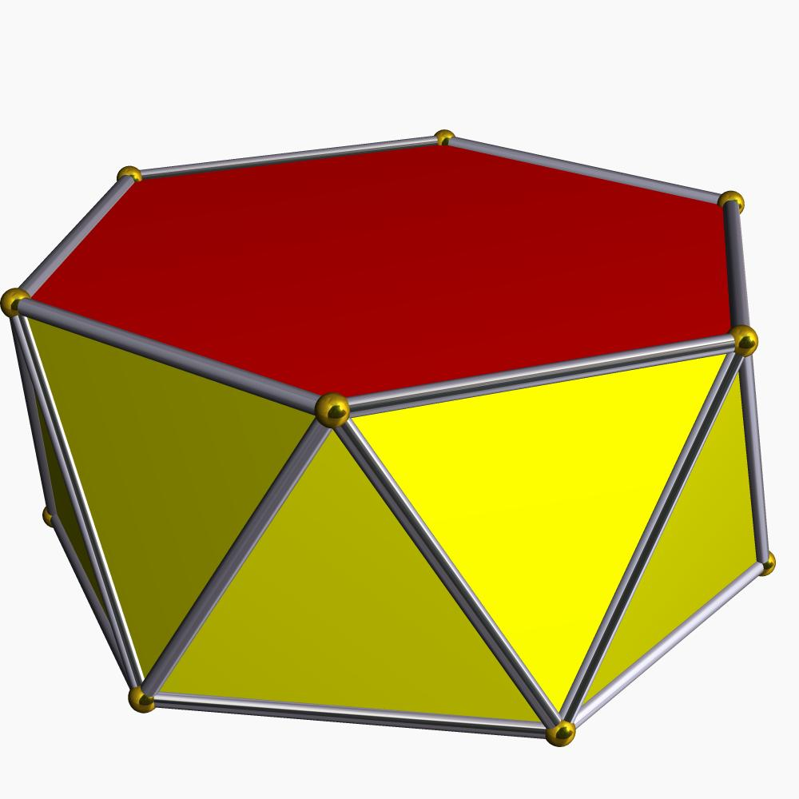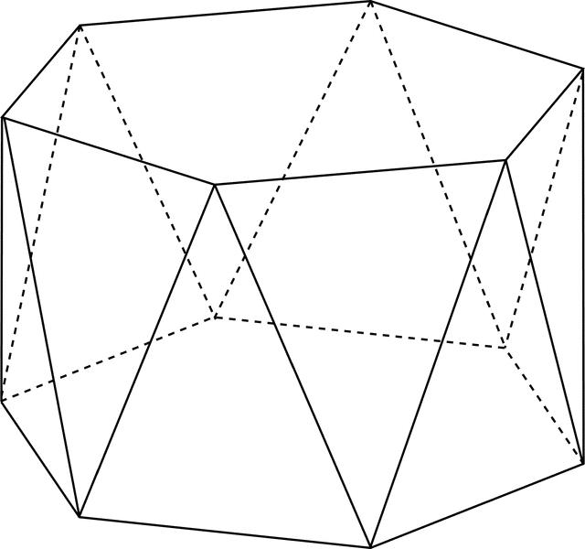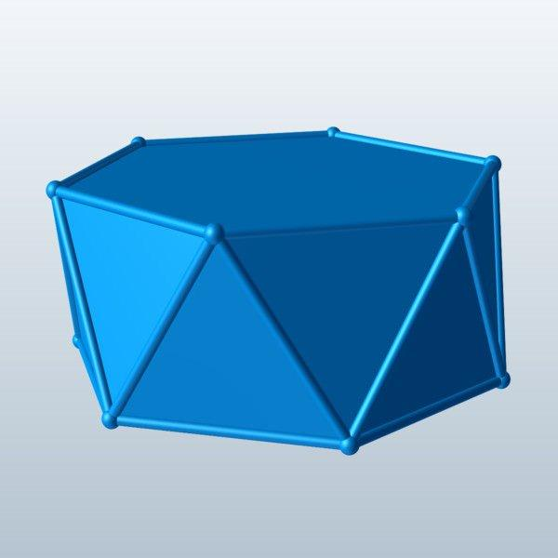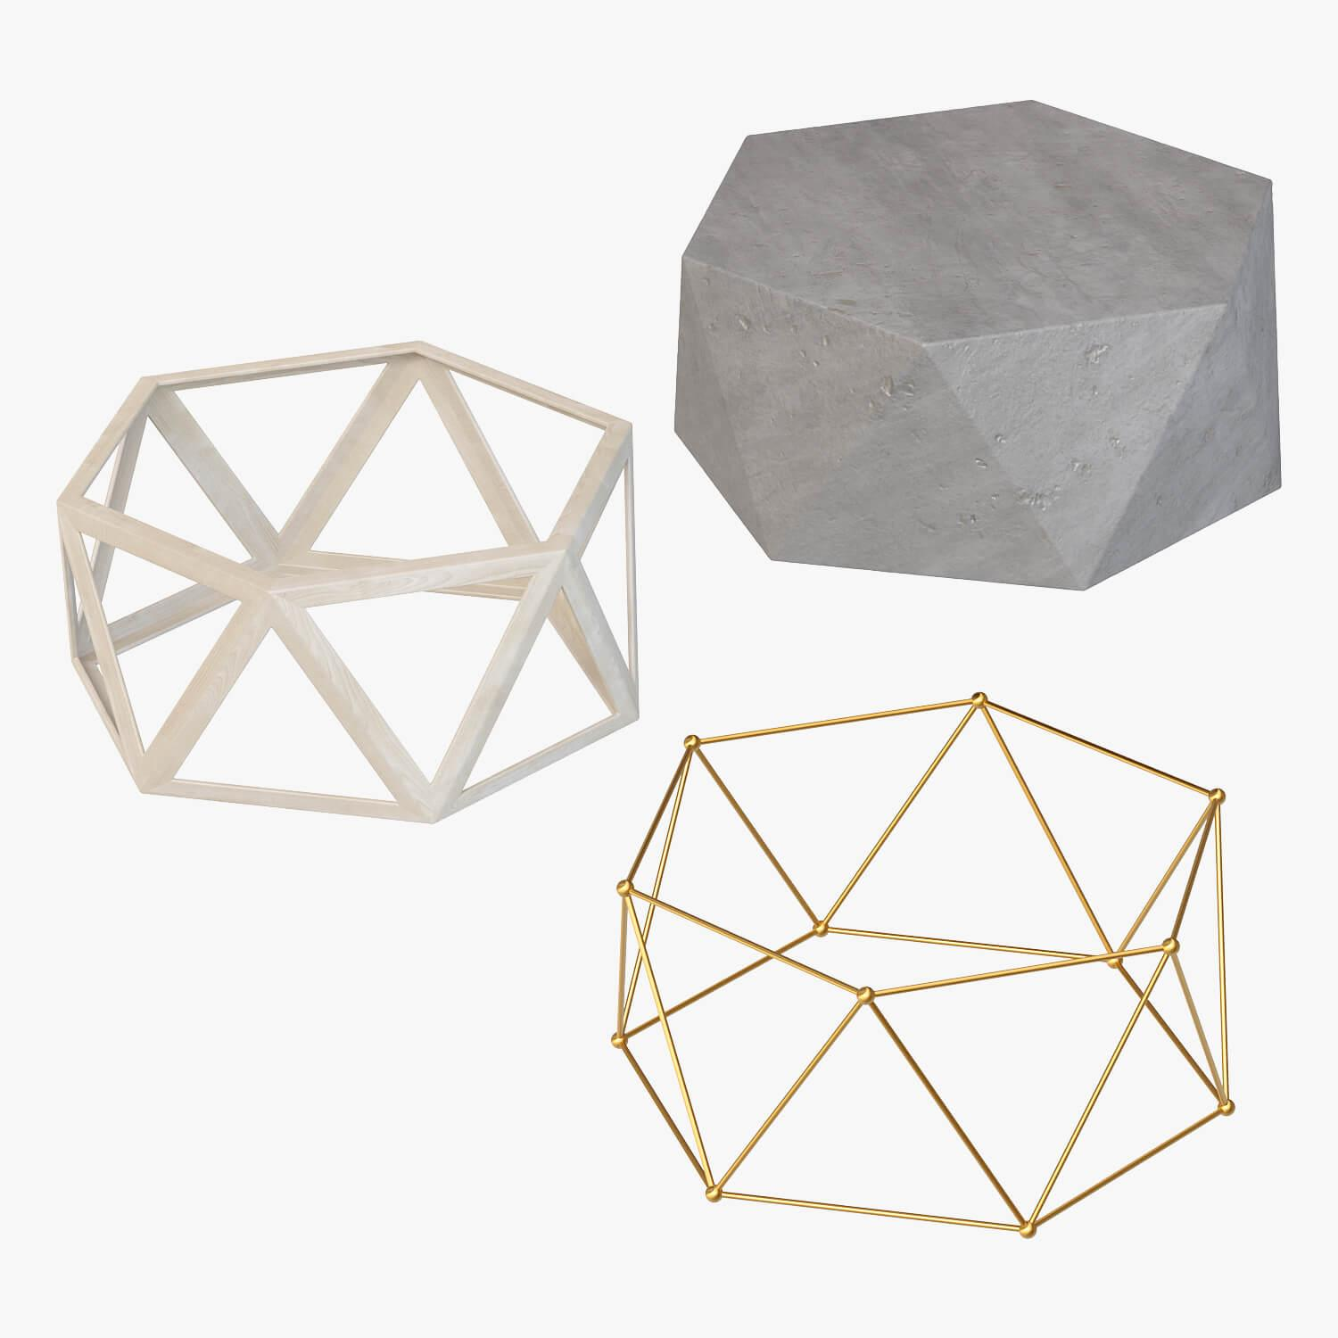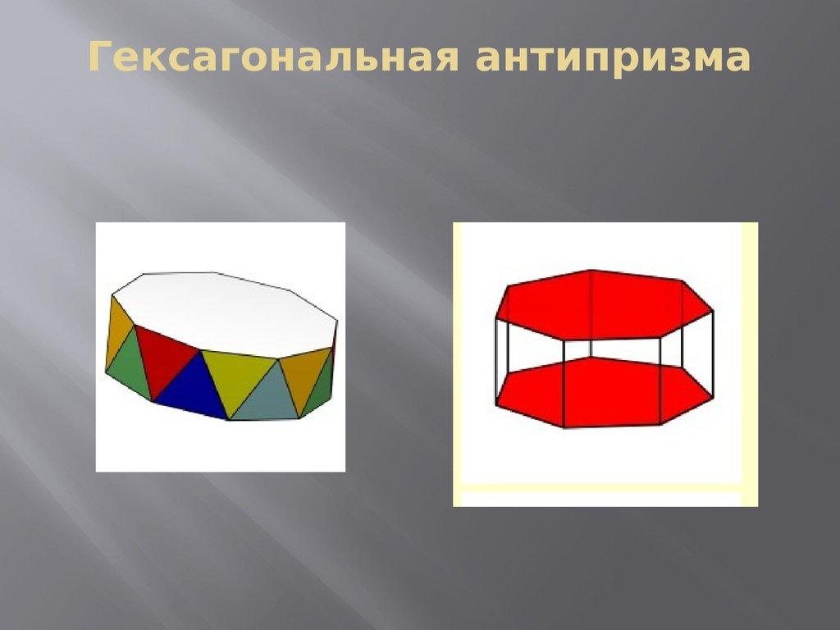

Geometric Structure
# Source: AI Source: Provided by: [Data Path: Persons Table -> ID Column: 1, Name_En Column: Motasem Essam] -> From: [ChatGPT] on [7/25/2026]
The hexagonal antiprism consists of:
- Upper Hexagonal Base: A hexagon forming the top face.
- Lower Hexagonal Base: A congruent hexagon forming the bottom face, rotated relative to the upper base.
- Triangular Lateral Faces: Twelve triangles connecting the two hexagonal bases.
- Vertices: Twelve vertices, with six on each base.
- Edges: Twenty-four edges connecting the vertices.

Face Composition
# Source: AI Source: Provided by: [Data Path: Persons Table -> ID Column: 1, Name_En Column: Motasem Essam] -> From: [ChatGPT] on [7/25/2026]
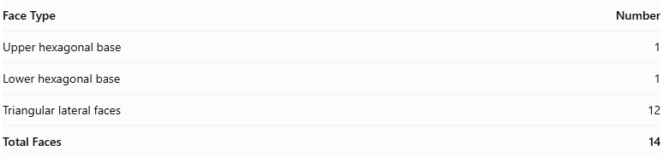
Face Type | Number
Upper hexagonal base | 1
Lower hexagonal base | 1
Triangular lateral faces | 12
Total Faces | 14

Mathematical Properties
# Source: AI Source: Provided by: [Data Path: Persons Table -> ID Column: 1, Name_En Column: Motasem Essam] -> From: [ChatGPT] on [7/25/2026]
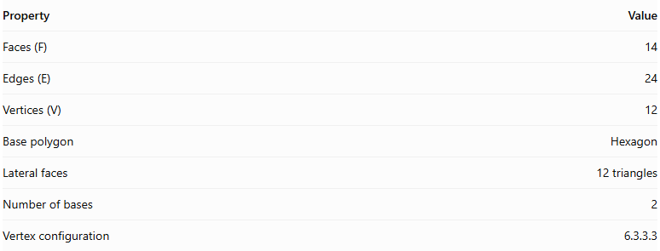
Property | Value
Faces (F) | 14
Edges (E) | 24
Vertices (V) | 12
Base polygon | Hexagon
Lateral faces | 12 triangles
Number of bases | 2
Vertex configuration | 6.3.3.3
Euler's formula:
$$V-E+F=2$$
$$12-24+14=2$$
Regular Hexagonal Antiprism
In a regular hexagonal antiprism:
- Both hexagonal bases are regular and congruent.
- The upper and lower bases are rotated relative to each other, typically by ${30}^{∘}$.
- The twelve lateral triangular faces are equilateral.
- The vertices have the same local arrangement.

Constructing Hexagonal Antiprism in Solid Geometry

Geometric Instruments Used
# Source: AI Source: Provided by: [Data Path: Persons Table -> ID Column: 1, Name_En Column: Motasem Essam] -> From: [ChatGPT] on [7/25/2026]
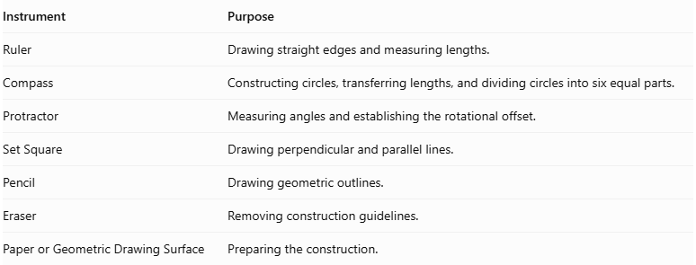
Instrument | Purpose
Ruler | Drawing straight edges and measuring lengths.
Compass | Constructing circles, transferring lengths, and dividing circles into six equal parts.
Protractor | Measuring angles and establishing the rotational offset.
Set Square | Drawing perpendicular and parallel lines.
Pencil | Drawing geometric outlines.
Eraser | Removing construction guidelines.
Paper or Geometric Drawing Surface | Preparing the construction.

Instrument-Based Construction Procedures
# Source: AI Source: Provided by: [Data Path: Persons Table -> ID Column: 1, Name_En Column: Motasem Essam] -> From: [ChatGPT] on [7/25/2026]
The hexagonal antiprism can be constructed using geometric instruments and classical geometric drawing techniques, without using coordinate-based construction.

Constructing the Lower Hexagonal Base
# Source: AI Source: Provided by: [Data Path: Persons Table -> ID Column: 1, Name_En Column: Motasem Essam] -> From: [ChatGPT] on [7/25/2026]
- Draw a circle using a compass.
- Divide the circle into six equal angular sections.
- Each central angle measures:
$$\frac{{360}^{∘}}{6}={60}^{∘}$$
- Mark the six vertices on the circumference.
- Connect consecutive vertices using a ruler to form a regular hexagon.
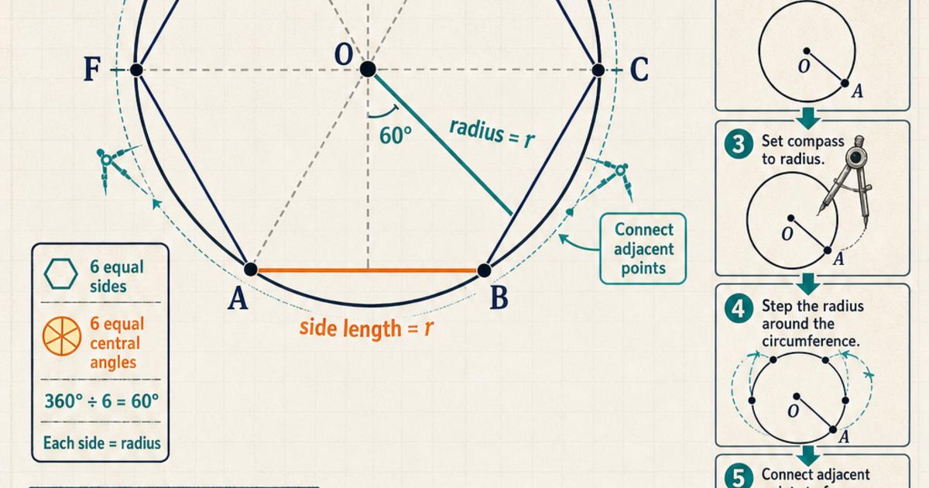

Constructing the Upper Hexagonal Base
# Source: AI Source: Provided by: [Data Path: Persons Table -> ID Column: 1, Name_En Column: Motasem Essam] -> From: [ChatGPT] on [7/25/2026]
- Draw a second regular hexagon congruent to the lower base.
- Position it above and parallel to the lower hexagon.
- Rotate its orientation by half the central angle:
$$\frac{{60}^{∘}}{2}={30}^{∘}$$
- Maintain the same side length and geometric proportions.
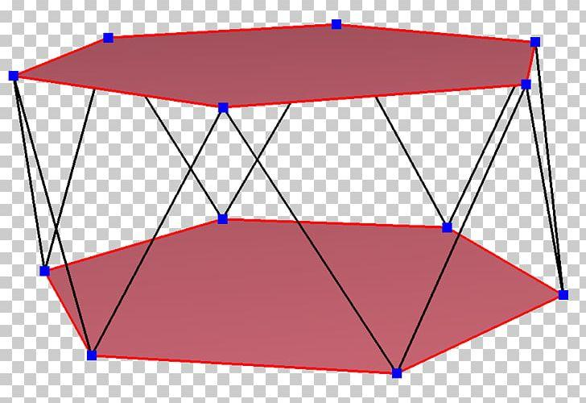

Connecting the Two Bases
# Source: AI Source: Provided by: [Data Path: Persons Table -> ID Column: 1, Name_En Column: Motasem Essam] -> From: [ChatGPT] on [7/25/2026]
- Connect each vertex of the lower hexagon to the two nearest vertices of the upper hexagon.
- Repeat the connections around the entire solid.
- Ensure the connecting edges alternate between the upper and lower bases.
- Form twelve triangular lateral faces.

Completing the Solid
# Source: AI Source: Provided by: [Data Path: Persons Table -> ID Column: 1, Name_En Column: Motasem Essam] -> From: [ChatGPT] on [7/25/2026]
- Complete all twelve triangular lateral faces.
- Emphasize the visible edges.
- Use dashed lines for hidden edges when necessary.
- Verify that both hexagonal bases are congruent and parallel.
- Check that the upper base has the correct 30° rotational offset.

Constructing a Net
# Source: AI Source: Provided by: [Data Path: Persons Table -> ID Column: 1, Name_En Column: Motasem Essam] -> From: [ChatGPT] on [7/25/2026]
A net of a hexagonal antiprism contains:
- Two congruent hexagonal bases.
- Twelve triangular lateral faces.
- A connected arrangement of faces with matching edge lengths and correct face adjacency.
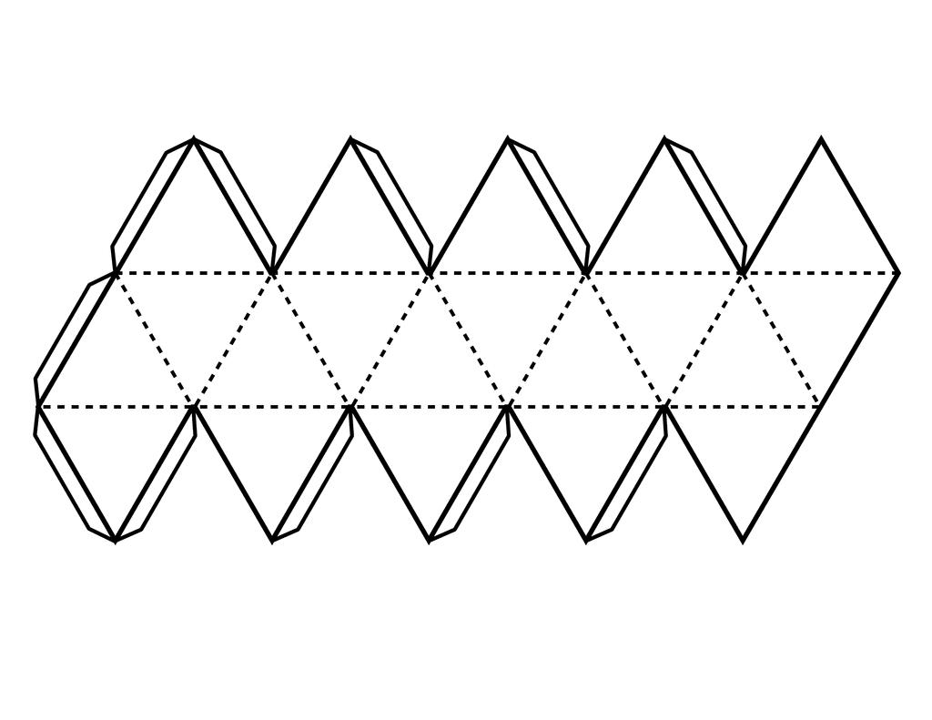

Key Points
# Source: AI Source: Provided by: [Data Path: Persons Table -> ID Column: 1, Name_En Column: Motasem Essam] -> From: [ChatGPT] on [7/25/2026]
- It has two parallel hexagonal bases.
- The bases are rotated relative to each other.
- It has twelve triangular lateral faces.
- It contains 14 faces, 24 edges, and 12 vertices.
- Its regular form is a uniform polyhedron.

Classification
# Source: AI Source: Provided by: [Data Path: Persons Table -> ID Column: 1, Name_En Column: Motasem Essam] -> From: [ChatGPT] on [7/25/2026]
Solid Geometry
└── Types of Solids
└── Antiprism
└── Types of Antiprisms
└── Hexagonal Antiprism
├── Upper Hexagonal Base
├── Lower Hexagonal Base
└── Triangular Lateral Faces

Conclusion
# Source: AI Source: Provided by: [Data Path: Persons Table -> ID Column: 1, Name_En Column: Motasem Essam] -> From: [ChatGPT] on [7/25/2026]
A Hexagonal Antiprism is an antiprism with two congruent hexagonal bases and twelve triangular lateral faces, arranged in a twisted configuration.

